* 1. **Background**

In today’s competitive business landscape, employee attrition has become a significant concern for organizations across various industries. High turnover rates disrupt business operations and lead to increased costs associated with recruitment, onboarding, and training new employees. Retaining key talent is crucial for maintaining productivity and fostering a healthy workplace culture. However, understanding the reasons behind employee attrition and predicting which employees are at risk of leaving is complex due to the multitude of influencing factors.

This research project focuses on the development of an employee attrition prediction system using machine learning techniques, aiming to provide organizations with insights into employee behavior and attrition trends. The system, built using Flask, a Python web framework, is designed to predict which employees are likely to leave based on historical employee data, enabling companies to take proactive measures to retain valuable talent. The project incorporates data analysis of employee records encompassing factors such as job satisfaction, performance ratings, salary, job role, work-life balance, and tenure. By identifying key drivers of attrition, the predictive model aims to forecast employee turnover accurately, providing HR teams with actionable insights.

Through the application of various machine learning algorithms, including Logistic Regression, the system learns patterns and relationships between employee characteristics and attrition. The integration of advanced data preprocessing and feature selection techniques ensures the predictive model is robust and interpretable. Leveraging data-driven decision-making, the Flask application helps organizations mitigate risks associated with high employee turnover by enabling real-time predictions and visualizations of attrition trends.

**1.2 Objectives**

The primary objective of this project is to develop an employee attrition prediction system using machine learning techniques that accurately forecasts which employees are at risk of leaving the organization. This predictive system aims to enable organizations to proactively identify and address the factors contributing to attrition, ultimately reducing turnover and enhancing employee retention strategies. The specific objectives of the project are as follows:

**1. Data Collection and Preprocessing:**

* Collect relevant employee data, including demographic information, job role, performance ratings, tenure, and work-life balance indicators.
* Clean and preprocess the data, handling missing values, outliers, and transforming categorical data into suitable formats for analysis.

**2. Exploratory Data Analysis (EDA):**

* Conduct exploratory data analysis to identify key patterns, trends, and relationships between different variables and employee attrition.
* Visualize the data using charts, histograms, and correlation heatmaps to gain insights into the factors most associated with turnover.

**3. Feature Selection and Engineering:**

* Identify and select the most significant features that contribute to employee attrition.
* Perform feature engineering to enhance the predictive power of the machine learning models.

**4. Model Development:**

* Develop multiple machine learning models, including Logistic Regression, Decision Trees, Random Forest, and Gradient Boosting, to predict employee attrition.
* Compare the performance of these models using key evaluation metrics such as accuracy, precision, recall, and F1 score.

**5. Model Optimization:**

* + Fine-tune the models through hyperparameter optimization to improve accuracy and generalization capabilities.
  + Select the best-performing model based on cross-validation results and test it on unseen data.

**6. Implementation and Integration:**

* + Implement the final predictive model in a Flask web application, allowing HR professionals to input employee data and receive real-time predictions on potential attrition risks.
  + Generate visualizations and actionable insights based on model outputs to assist organizations in developing retention strategies.

**7. Evaluate and Validate the System:**

* + Evaluate the system’s performance by analyzing its prediction accuracy on test datasets.
  + Validate the system’s utility by assessing its effectiveness in helping HR teams identify at-risk employees and reduce turnover rates.

**1.3 Purpose, Scope, and Applicability**

**1.3.1 Purpose**

The purpose of this project is to develop a machine learning-based employee attrition prediction system that helps organizations identify employees at risk of leaving. By providing HR teams with predictive insights through a user-friendly Flask web application, the system aims to support proactive retention strategies and reduce turnover rates. The project explores how various factors—such as job satisfaction, salary, performance, and work-life balance—contribute to attrition and leverages these insights to build an accurate predictive model. Ultimately, the goal is to enhance talent management by enabling organizations to address the underlying causes of attrition and implement targeted interventions to retain valuable employees.

**1.3.2 Scope**

The scope of the project encompasses the entire process of building a predictive system for employee attrition, from data collection to model deployment. This includes:

**1. Data Collection:** Gathering data from employee records, including demographics, job performance, role, and work-related attributes.

**2. Data Preprocessing and Analysis:** Cleaning, transforming, and analyzing the data to identify key factors influencing attrition.

**3. Model Development:** Developing and testing various machine learning models such as Logistic Regression, Decision Trees, Random Forest, and Gradient Boosting to predict employee attrition.

**4. Model Evaluation:** Evaluating the models using performance metrics like accuracy, precision, recall, and F1 score to determine the most effective one.

**5. System Implementation:** Creating a practical Flask application that allows HR professionals to input employee data and receive predictions on potential attrition risks.

**6. Recommendations and Insights:** Providing insights based on model predictions to assist in the creation of retention strategies.

**7. Future Enhancements:** Suggestions for system scalability and integration with other HR tools, as well as potential improvements to the prediction models.

The scope does not include live implementation with a specific organization or real-time updates of employee data, but it does account for a scalable system adaptable for various industries.

**1.3.3 Applicability**

The system is applicable to organizations of all sizes across various industries experiencing challenges with employee turnover. It can be utilized by HR teams, managers, and decision-makers to:

**1. Proactively Identify At-Risk Employees:** Predicting which employees are likely to leave allows organizations to target retention efforts more effectively, reducing the need for reactive measures.

**2. Optimize Retention Strategies:** Insights provided by the system help HR professionals develop strategies tailored to employees' needs and concerns, enhancing job satisfaction and work-life balance.

**3. Improve Workforce Planning:** Understanding attrition trends aids organizations in better planning for recruitment, succession, and resource allocation.

**4. Enhance Employee Engagement:** Early identification of dissatisfaction factors allows for targeted interventions to improve engagement and morale, creating a more positive work environment.

This system is particularly beneficial in industries with high turnover rates, such as retail, hospitality, customer service, and technology, but is flexible enough to be adapted to any organization aiming to improve its retention rates and employee satisfaction.

**2.1 Problem Definition**

Employee attrition is a significant challenge for organizations, leading to loss of talent, increased recruitment costs, and disruption of team dynamics. Predicting which employees are likely to leave can help human resource departments take preemptive actions to retain them. The goal of this project is to develop a machine learning model that can predict employee attrition based on a variety of factors, such as age, job role, satisfaction levels, and more. By analyzing historical employee data, the model will provide insights into the causes of attrition and help organizations develop effective retention strategies.

**2.2 Requirement Specification**

In developing the employee attrition prediction system, specific requirements were identified to ensure successful project execution. These requirements include data, system, and model specifications for both the machine learning model and the interactive web application.

**2.2.1 Requirement Gathering**

Data for this project was gathered from two main sources:

1. Google Forms: Employee-related data was collected through a custom survey designed to gather detailed information on work conditions, job satisfaction, and personal demographics. A total of 500 responses were collected through this survey. The survey can be accessed (https://docs.google.com/forms/d/1LXbgK1Ey0IiE8nQiWCdomNvd_ZER5wU2gkmr_9XZKNU/editsettings).

**The questions included in the survey are as follows:**

**1. Enter full name**

**2. Email**

**3. Phone number**

**4. Age:**

- Below 25

- 20-30

- 30-40

- 40-50

**5. Which department are you working in?**

- HR

- Sales

- IT

- Finance

- Marketing

- Other

**6. What is your highest qualification?**

- Below college (10th)

- College (12th)

- Bachelor's Degree

- Master's Degree

- PhD or a Doctorate

**7. Attrition - Have you left the organization?**

- Yes

- No

**8. Business Travel - Do you travel for business?**

- Frequently

- Occasionally

- Rarely

- Never

**9. Daily Rate: What is your daily salary rate? (Enter amount)**

**10. Distance from home: How far do you live from the office?**

- Less than 5 km

- 5 - 10 km

- 10 - 20 km

- 20 - 30 km

- More than 30 km

**11. Educational Field:**

- Engineering

- Business

- Science

- Arts

- Medical

- Others

**12. What is your current job role?**

**13. Job Satisfaction - How satisfied are you with your job?**

- 1

- 2

- 3

- 4

- 5

**14. Marital Status - What is your marital status?**

- Single

- Married

- Divorced

**15. Monthly Income - What is your monthly income (in your local currency)?**

**16. Number of Companies Worked For - How many companies have you worked for?**

**17. Over Time - Do you work overtime?**

- Yes

- No

**18. Percent Salary Hike - What percentage was your last salary hike?**

**19. Years in Current Role - How many years have you been in your current role?**

**20. Years Since Last Promotion - How many years since your last promotion?**

**2. Kaggle Dataset:** A dataset from Kaggle provided additional features, such as employee tenure, education levels, and performance ratings. These datasets were combined to form a comprehensive dataset for model training and evaluation.

The dataset contains the following fields, which are crucial for building the attrition prediction model:

* + Age: Employee's age.
  + Attrition: Whether the employee has left the company (Yes/No).
  + BusinessTravel: Frequency of employee's business travel.
  + DailyRate: Employee's daily pay rate.
  + Department: Department where the employee works (e.g., Sales, HR).
  + DistanceFromHome: Distance between employee's home and workplace.
  + Education: Employee's education level (1-5).
  + EducationField: Field of study for the employee's highest degree.
  + EmployeeCount: Number of employees (constant for all records).
  + EmployeeNumber: Unique identifier for the employee.
  + EnvironmentSatisfaction: Employee’s satisfaction with the work environment (1-4).
  + Gender: Employee's gender (Male/Female).
  + HourlyRate: Hourly wage of the employee.
  + JobInvolvement: Employee’s involvement in their job (1-4).
  + JobLevel: Level of the employee's role in the company.
  + JobRole: Job title/role (e.g., Manager, Sales Executive).
  + JobSatisfaction: Employee's satisfaction with their job (1-4).
  + MaritalStatus: Employee's marital status (e.g., Single, Married).
  + MonthlyIncome: Employee's monthly salary.
  + MonthlyRate: Employee's monthly pay rate.
  + NumCompaniesWorked: Number of companies the employee has worked at.
  + Over18: Whether the employee is over 18 years old (constant: Yes).
  + OverTime: Whether the employee works overtime (Yes/No).
  + PercentSalaryHike: Percentage increase in salary.
  + PerformanceRating: Employee's performance rating (1-4).
  + RelationshipSatisfaction: Employee’s satisfaction with personal relationships at work (1-4).
  + StandardHours: Standard working hours (constant: 80).
  + StockOptionLevel: Level of stock options given to the employee (0-3).
  + TotalWorkingYears: Total number of years the employee has worked.
  + TrainingTimesLastYear: Number of training sessions attended last year.
  + WorkLifeBalance: Employee's work-life balance satisfaction (1-4).
  + YearsAtCompany: Number of years the employee has been with the company.
  + YearsInCurrentRole: Number of years the employee has been in their current role.
  + YearsSinceLastPromotion: Number of years since the employee's last promotion.
  + YearsWithCurrManager: Number of years the employee has worked with their current manager.

**2.2.2 Requirement Analysis**

The dataset underwent a thorough analysis to determine which features were most relevant for predicting employee attrition. Various preprocessing techniques, including label encoding and oversampling, were used to prepare the data for modeling. The following steps were involved in analyzing the data:

**1. Data Cleaning:**

* Removed null or inconsistent data entries to ensure the dataset's integrity.
* Converted categorical values in the 'Attrition' column from 'No' and 'Yes' to binary numerical values (0 for 'No' and 1 for 'Yes').
* Mapped the 'OverTime' column from categorical to binary numerical values (0 for 'No' and 1 for 'Yes').
* Mapped the 'Gender' column to binary numerical values (0 for 'Male' and 1 for 'Female').
* Dropped unnecessary columns, such as 'Over18', and excluded the target variable 'Attrition' from the feature set before modeling.

**2. Feature Engineering:**

* Encoded categorical variables using `LabelEncoder` for the columns: 'BusinessTravel', 'Department', 'EducationField', 'JobRole', and 'MaritalStatus'. This transformed the categorical data into a numerical format suitable for modeling.

**3. Balancing the Dataset:**

Addressed class imbalance in the target variable by using the `RandomOverSampler` technique to oversample the minority class (attrition = 1), ensuring it was adequately represented in the dataset.

**4. Exploratory Data Analysis (EDA):**

* Conducted EDA through visualizations such as histograms, correlation heatmaps, and count plots to identify patterns and relationships that could impact attrition. Various visualizations were created to explore the count of attrition, attrition by department, education field, job role, gender, age distribution, and education level.
* Calculated statistical metrics like the confusion matrix and ROC curve to evaluate the model's performance.

**3 TECHNOLOGY UTILIZED**

**3.1 Software Components**

The following software components were critical to the development of the employee attrition prediction system:

**1. Programming Language: Python 3.x**

Python was chosen as the core programming language for this project due to its rich ecosystem of libraries for data analysis, machine learning, and web development. Python's versatility and ease of use make it ideal for building end-to-end data-driven applications.

**2. Web Framework: Flask**

Flask, a lightweight web framework, was used to build the front-end of the application. Flask’s simplicity and flexibility allowed the creation of a robust yet user-friendly web interface where users can upload datasets, run machine learning models, and view the results through visualizations.

**3. Machine Learning Libraries**

* 1. **scikit-learn:** This widely used machine learning library provided various algorithms such as Logistic Regression, Decision Trees, and Random Forest, along with tools for model evaluation and performance metrics.
  2. **pandas:** Used for handling and preprocessing the data, pandas made it easy to manipulate CSV files, clean the dataset, and extract valuable insights.
  3. **matplotlib and seaborn**: These libraries were essential for data visualization. They facilitated plotting the distribution of features and visualizing model performance metrics such as confusion matrices, playing a crucial role in making the analysis more interpretable.
  4. **imbalanced-learn:** In employee attrition datasets, there is often a class imbalance, with significantly fewer employees leaving than staying. The `imbalanced-learn` library helped address this issue by providing techniques like Random Over-Sampling to balance the dataset.

**4. HTML Templates**

HTML templates were used to render the web pages, allowing users to interact with the system. Flask’s templating engine, Jinja, helped dynamically generate these pages based on user inputs and machine learning model outputs.

**Technologies Used**

**Flask**

Flask is a micro-framework written in Python that provides the necessary tools for developing web applications with minimal overhead. Flask's flexibility made it an excellent choice for this project, as it allowed the development of a lightweight, scalable, and easy-to-maintain web application.

pandas

pandas is a powerful Python library used for data manipulation and analysis. It allows users to work with structured data (such as CSV files) and offers functionalities for filtering, cleaning, and transforming datasets. pandas is essential for preprocessing the employee dataset before it is fed into the machine learning models.

**scikit-learn**

scikit-learn is one of the most popular machine learning libraries in Python, providing simple and efficient tools for data mining, data analysis, and machine learning. The project relies on scikit-learn for implementing various algorithms such as Logistic Regression, Decision Trees, and Random Forest, as well as evaluating the models using metrics like accuracy, precision, recall, and ROC AUC.

**matplotlib and seaborn**

These libraries are used for creating static, animated, and interactive visualizations. `matplotlib` is a comprehensive library for creating a wide range of plots, while `seaborn` is built on top of `matplotlib` and provides a higher-level interface for creating aesthetically pleasing and informative graphics.

**imbalanced-learn**

imbalanced-learn is a Python library designed to handle imbalanced datasets. Employee attrition datasets often exhibit class imbalance, where the number of employees staying with the company far exceeds those leaving. The imbalanced-learn library helps balance the dataset by oversampling the minority class (employees who left), ensuring that the machine learning models are not biased towards the majority class.

**3.2 Hardware Components**

Processor: Intel Core i5 or AMD Ryzen 5 (or equivalent).

RAM: Minimum 8 GB (16 GB recommended for larger datasets).

Storage: 256 GB SSD for faster data access.

GPU (optional): NVIDIA GTX 1650 or higher for advanced tasks.

Operating System: Windows, macOS, or Linux.

**4 METHODOLOGY**

Methodology section for your employee attrition prediction project, elaborating on each step involved in data preparation, cleaning, model training, and testing:

**4.1. Data Preparation**

The first step in the project was to prepare the dataset for analysis. This phase encompassed several important tasks to ensure that the data was ready for processing:

**File Uploading:** A user-friendly web interface was implemented using Flask, allowing users to upload a CSV file containing employee data. This design choice not only enhanced accessibility but also streamlined the data input process, enabling users to easily integrate their datasets into the system.

**Data Loading:** Upon successful file upload, the CSV file was read into a Pandas DataFrame. This process involved validating the file format and ensuring that the data was properly structured. The DataFrame served as the primary data structure for subsequent data manipulation and analysis, allowing for efficient handling of large datasets.

**4. 2. Data Cleaning**

Data cleaning was a critical phase aimed at enhancing the quality of the dataset and making it suitable for machine learning models. The following techniques were employed:

* + **Categorical Conversion**: To facilitate the modeling process, categorical columns such as 'Attrition', 'OverTime', and 'Gender' were transformed from string representations into binary numerical values. This conversion was essential because machine learning algorithms typically require numerical input. The specific transformations included:
  + 'Attrition': Mapped from categorical values ('No', 'Yes') to binary values (0 for 'No', 1 for 'Yes').
  + 'OverTime': Mapped from categorical values ('No', 'Yes') to binary values (0 for 'No', 1 for 'Yes').
  + 'Gender': Mapped from categorical values ('Male', 'Female') to binary values (0 for 'Male', 1 for 'Female').
  + **Label Encoding:** In addition to binary conversion, other categorical variables, including 'BusinessTravel', 'Department', 'EducationField', 'JobRole', and 'MaritalStatus', were encoded into numerical values using the `LabelEncoder` from the Scikit-learn library. This process involved transforming each unique category within these features into corresponding numerical representations, ensuring that all categorical data was appropriately formatted for modeling.
  + **Dropping Unnecessary Columns:** To focus on the relevant features for modeling, unnecessary columns such as 'Over18' were removed. Furthermore, the target variable 'Attrition' was separated from the feature set. This step was crucial for reducing dimensionality and eliminating any potential noise from the dataset, thus enhancing the model's performance.

**4. 3. Model Training**

With the data cleaned and prepared, the next phase focused on training the predictive model. The following steps were integral to this process:

**- Handling Class Imbalance:** Employee attrition is often characterized by imbalanced classes, with significantly more employees staying than leaving. To address this issue, the `RandomOverSampler` technique from the `imblearn` library was employed to oversample the minority class (attrition = 1). This approach not only helped balance the dataset but also aimed to improve the model's ability to correctly predict attrition. By ensuring that both classes were adequately represented, the model could learn more effectively from the data.

**- Train-Test Split:** The balanced dataset was then divided into training and testing sets using an 80-20 split. This division was essential to evaluate the model's performance on unseen data. The training set was used to train the model, while the testing set served as a benchmark to assess the model’s predictive capabilities.

**- Logistic Regression:** A logistic regression model was selected for training due to its suitability for binary classification problems. Logistic regression is advantageous for several reasons:

- It is relatively simple and interpretable, allowing stakeholders to easily understand the model’s decision-making process.

- The algorithm provides probabilistic outputs, enabling the estimation of the likelihood of an employee leaving the organization.

- Logistic regression is effective in handling linear relationships, making it a reliable choice for this specific problem. The model was trained on the prepared training data, optimizing the coefficients to best fit the relationships within the dataset.

**4.4. Model Testing**

The final phase involved a comprehensive evaluation of the trained model using a variety of metrics to ascertain its effectiveness and reliability:

**Prediction:** Once the model was trained, predictions were generated for the testing dataset. This step involved applying the trained model to the features of the testing set to predict the likelihood of attrition for each employee. By using the model's output probabilities, we categorized employees into two classes: those predicted to leave and those expected to stay. This classification allows for targeted interventions and better resource allocation to address potential attrition.

**Confusion Matrix**: A confusion matrix was created to assess the model’s accuracy and to identify the true positive, true negative, false positive, and false negative rates. The confusion matrix provides a clear view of the model's performance in predicting both classes, allowing for a straightforward evaluation of its strengths and weaknesses. The key metrics derived from the confusion matrix include:

- True Positives (TP): Employees who were predicted to leave and actually did.

- True Negatives (TN): Employees who were predicted to stay and did stay.

- False Positives (FP): Employees who were predicted to leave but did not.

- False Negatives (FN): Employees who were predicted to stay but left.

From these values, various performance metrics can be calculated, such as accuracy, precision, recall, and F1-score, which provide insights into the model’s performance in different contexts.

**ROC Curve:** The receiver operating characteristic (ROC) curve was constructed, and the area under the curve (AUC) metric was computed. The ROC curve illustrates the model's performance across different classification thresholds, showcasing the trade-off between true positive rates (sensitivity) and false positive rates (1-specificity). AUC quantifies the overall ability of the model to discriminate between the two classes; a value closer to 1 indicates better performance, whereas a value of 0.5 suggests no discrimination capability (equivalent to random guessing). The ROC curve also helps in selecting the optimal threshold for classification, balancing sensitivity and specificity based on the business objectives.

**5. SYSTEM OUTPUT**



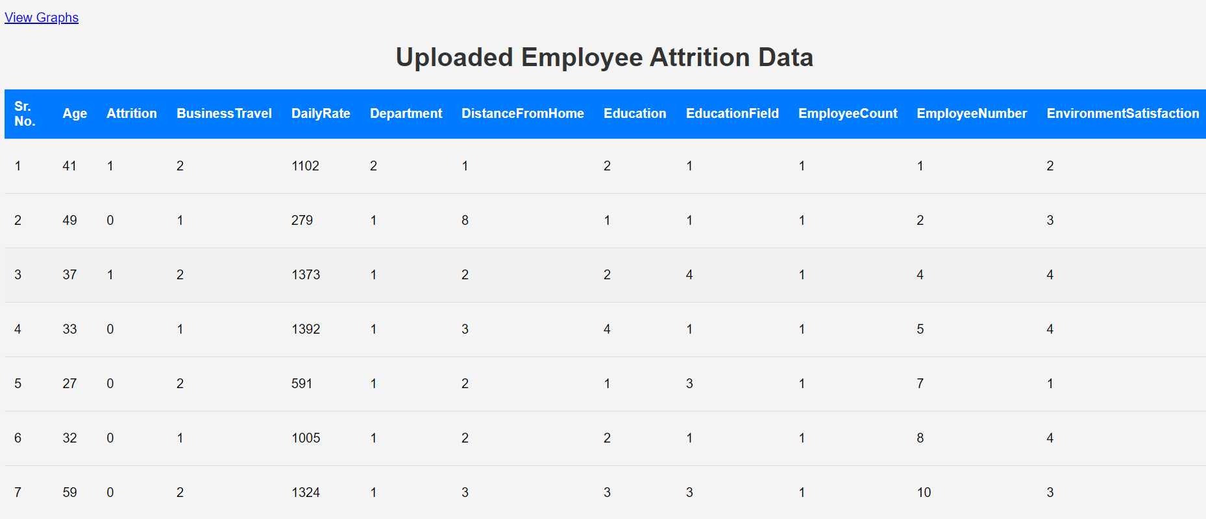

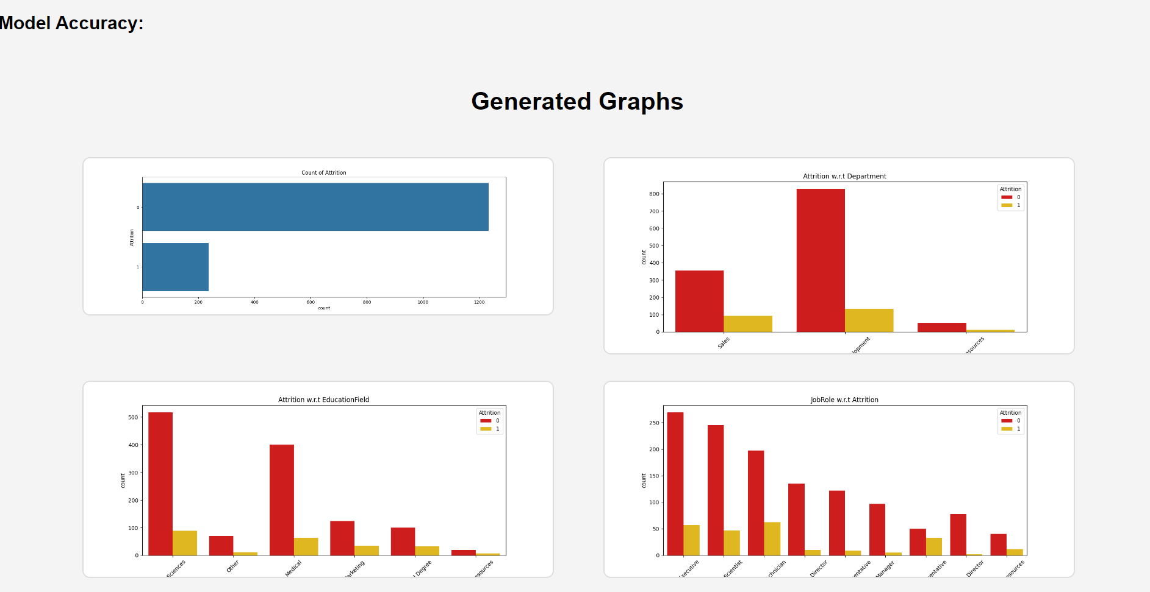

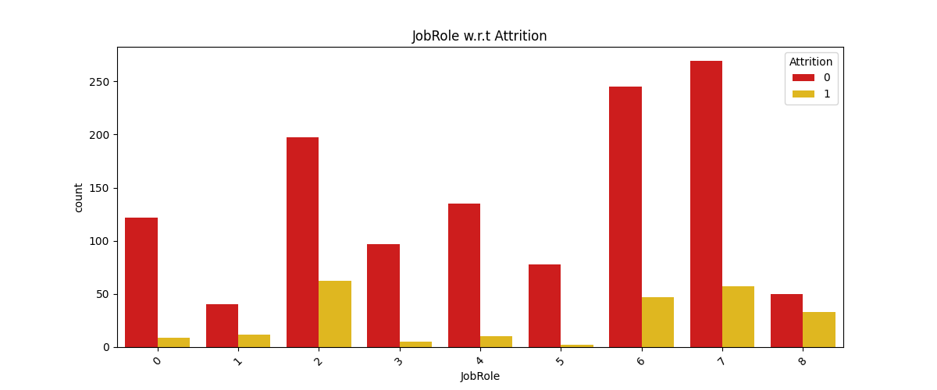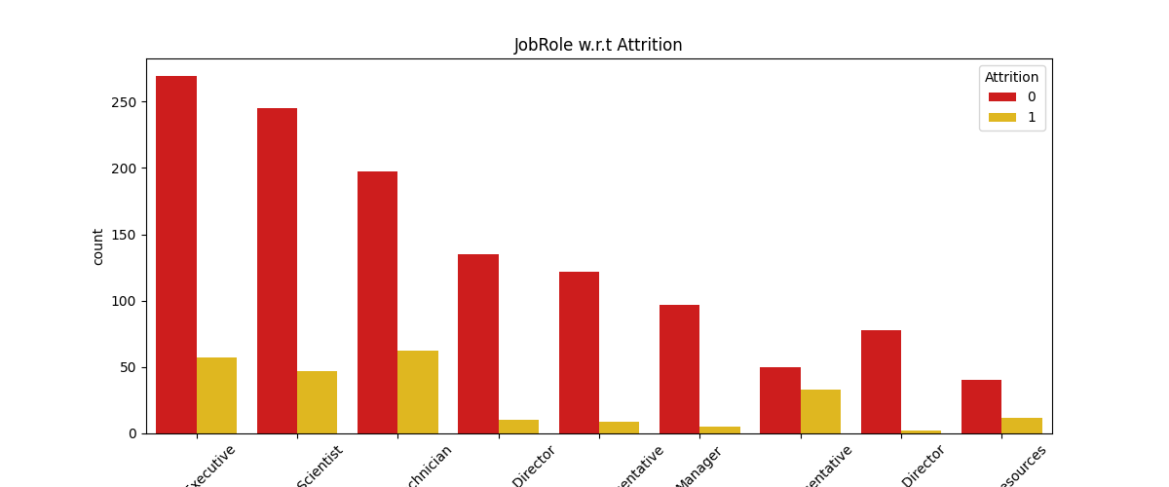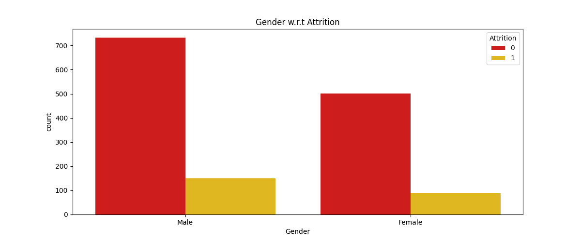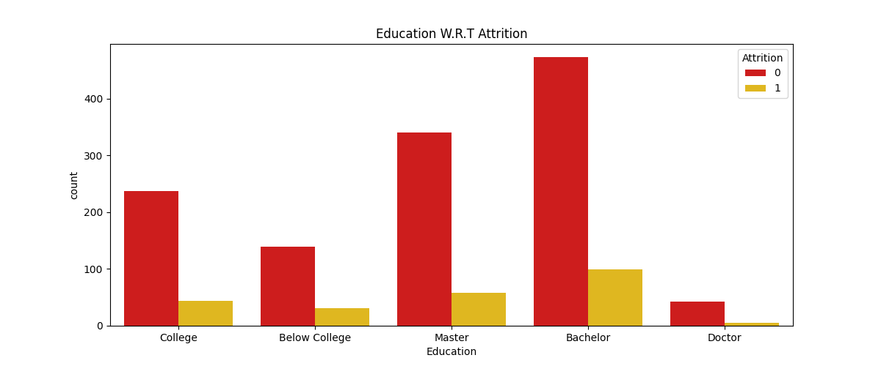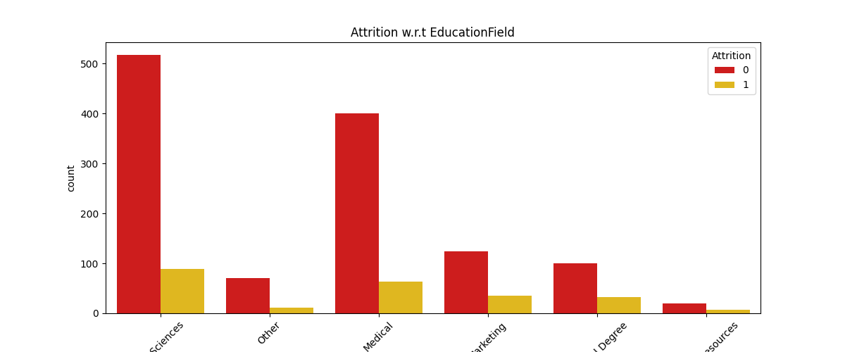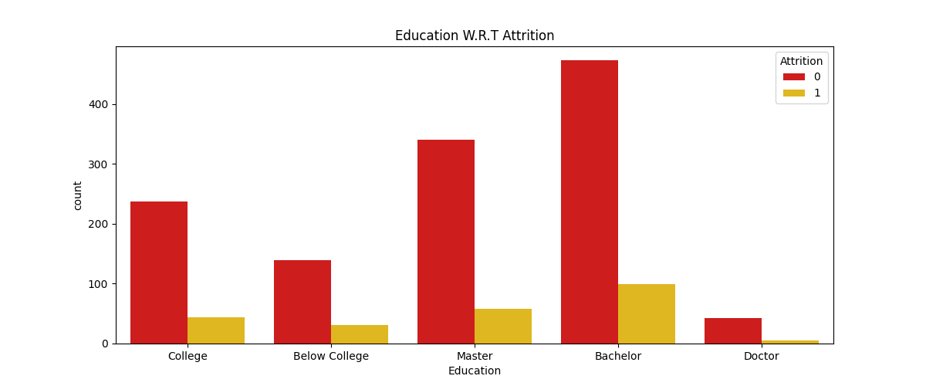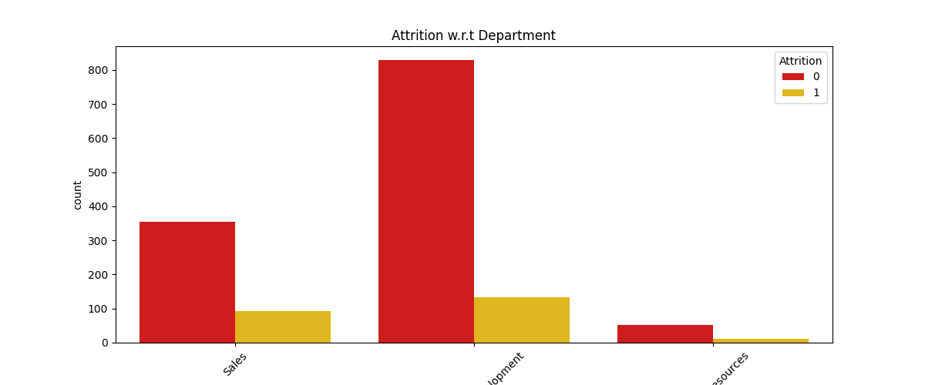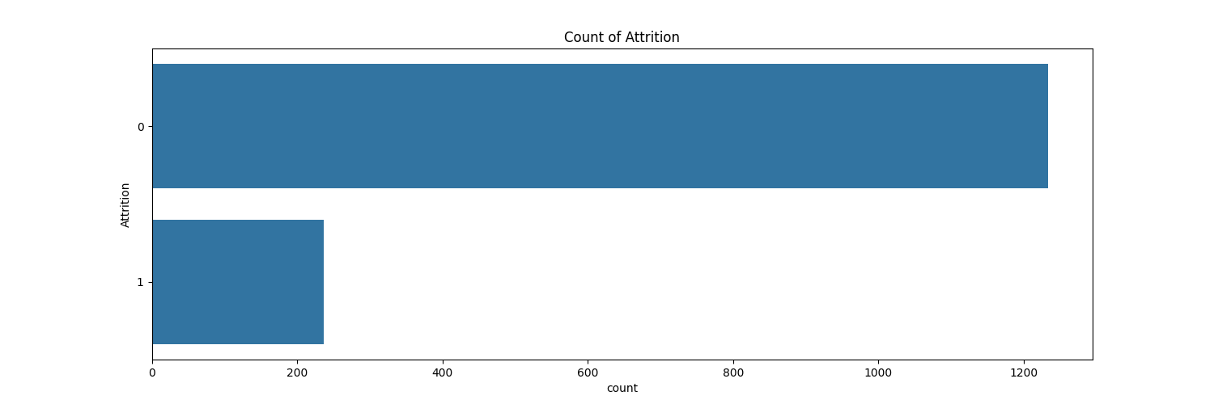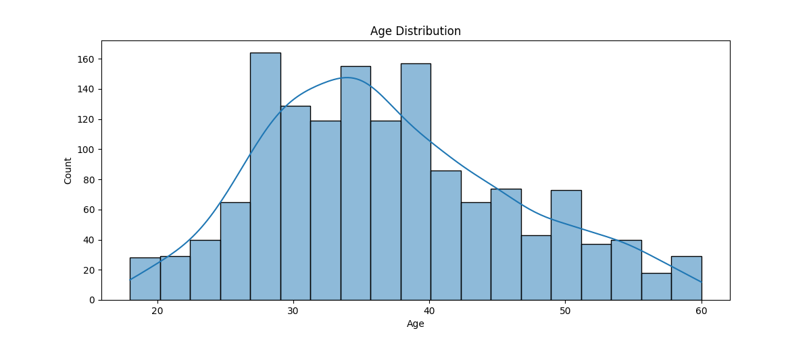

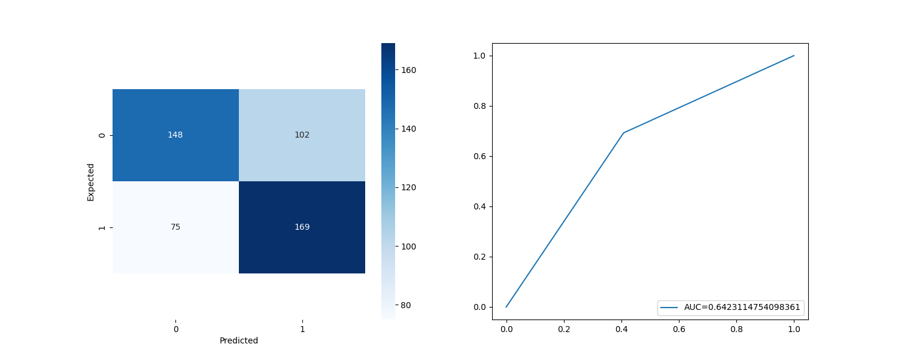

**6. DEPLOYMENT**

Deploying a project to Railway.app using the GitHub repositories option involves several steps to ensure that your application is built, deployed, and maintained seamlessly. Here's a detailed guide explaining the process, the steps you're taking, and what happens behind the scenes when deploying your project from GitHub to Railway:

Railway.app is a cloud platform that simplifies the deployment process by providing an easy-to-use interface to deploy web applications and services. It abstracts away much of the complexity involved in building and managing infrastructure, allowing developers to focus more on writing code and less on dealing with complex DevOps tasks. Railway.app integrates with GitHub, making it a breeze to deploy projects directly from your repository.

Steps to Deploy a Project on Railway.app from GitHub

**Step 1: Sign Up / Log In to Railway.app**

- Visit: Navigate to [Railway.app](https://railway.app/) and either sign up or log in. You can sign up using your GitHub account, which will simplify the integration process later on.

- Create a Project: After logging in, you'll land on the Railway dashboard. Click the "New Project" button to start the deployment process.

**Step 2: Connect Railway to Your GitHub Repository**

- Choose GitHub Repos Option: After clicking "New Project," select the "Deploy from GitHub Repo" option. Railway will ask for permission to access your GitHub repositories.

- Grant Access: You will be redirected to GitHub, where you need to grant Railway the required permissions to access your repositories. Choose the repository that contains the project you want to deploy.

**Step 3: Select the GitHub Repository for Deployment**

- Choose Repository: Once Railway has access to your GitHub account, you'll see a list of all repositories in your GitHub account. Select the one that contains the project you wish to deploy. This repository should have all the necessary code and configuration files required to build and run the application (like `Dockerfile`, `.railway`, or `Procfile`).

**Step 4: Configure the Environment and Deployment Settings**

- Set up Variables and Secrets: Many projects require environment variables for things like database connections, API keys, or other configurations. In Railway, you can easily add environment variables under the project settings

- Select Branch: You may choose which branch of your GitHub repository Railway should deploy. Typically, the `main` or `master` branch is selected for production environments, but you can also deploy from a feature or development branch.

**Step 5: Railway Begins the Build Process**

- Automated Build Process: Once the repository is selected, Railway kicks off the build process. Behind the scenes, it does the following:

- Pulls the Code: Railway fetches the code from the GitHub repository, downloading the latest commit on the selected branch.

- Detects Build Requirements: Railway automatically tries to detect the necessary environment to build and run the project. It looks for files like `Dockerfile`, `package.json` (for Node.js), `requirements.txt` (for Python), or other build configuration files.

- Installs Dependencies: Railway automatically installs any dependencies defined in your project. For instance, if it detects a `package.json`, it will run `npm install` or `yarn install`. If it’s a Python project, it will install dependencies listed in `requirements.txt` using `pip`.

- Building the Docker Image (If Applicable): If your project contains a `Dockerfile`, Railway will use Docker to build the container image. The `Dockerfile` tells Railway how to build the environment, install dependencies, and set up the application.

- Running the Dockerfile: If your project has a `Dockerfile`, Railway executes the instructions in that file step-by-step. The Docker image will include all the necessary system libraries, configurations, and files required to run the app.

**Step 6: Deploying the Application**

- Provisioning Infrastructure: Railway handles all the necessary infrastructure setup, including servers, databases, and networking. It abstracts away the need to manually provision or manage cloud servers.

- Running the Application: Once the build process is complete, Railway deploys the application to its cloud infrastructure. If everything is configured correctly, your app should be up and running on a unique Railway-provided URL (or a custom domain, if configured).

- Log Monitoring: As the application starts running, Railway provides real-time logs that can be accessed from the dashboard. These logs show the output from your server, build errors, and deployment status. You can monitor your app's performance, view requests, and handle any issues directly through the Railway interface.

**Step 7: Continuous Deployment and Updates**

- Continuous Deployment (CD): One of the key benefits of deploying via GitHub is that Railway supports continuous deployment. Anytime you push a new commit to the linked branch, Railway will automatically trigger a new deployment. This means your latest changes from GitHub will be continuously deployed without manual intervention.

- Rollback Option: If a new deployment breaks something in your app, Railway provides a rollback option to restore your app to the previous working version.

**Step 8: Add-ons (Databases, Storage, etc.)**

- Database Setup: If your project requires a database (like MySQL, PostgreSQL, or Redis), Railway offers an easy way to add databases as add-ons. You can connect your project to a Railway-managed database, and Railway will handle provisioning, scaling, and backup.

- Storage and Other Add-ons: Besides databases, Railway also offers additional add-ons such as cloud storage and other integrations. These can be managed directly from the dashboard.

**Step 9: Monitor and Scale the Application**

- Monitoring Performance: Railway offers monitoring tools to keep an eye on resource usage like CPU, memory, and network requests. You can use these insights to optimize your application.

- Auto-Scaling: As your user base grows, Railway automatically scales the resources available to your app to ensure it remains responsive and fast.

**Step 10: Access the Application**

- Access URL: Once the deployment is successful, Railway provides a public URL for your application. You can share this link with users to access your deployed project. Additionally, if you prefer, you can map a custom domain to this URL for a more professional look.

**Benefits of Using Railway.app with GitHub**

**1. Ease of Use:** The integration between Railway and GitHub makes deploying code straightforward. There's no need to manually manage servers, configure deployment pipelines, or monitor infrastructure health.

**2. CI/CD Integration**: With the continuous deployment feature, any changes pushed to the GitHub repository are automatically deployed to production, making it perfect for agile development practices.

**3. Infrastructure Abstraction:** Railway manages the backend infrastructure, allowing you to focus on code rather than server management.

**4. Scalability**: Railway automatically scales your project based on traffic and resource demands, ensuring your app can handle spikes in traffic without manual intervention.

**5. Environment Variables and Secrets Management:** Railway provides an easy way to manage environment variables, securely handling sensitive information like API keys or database passwords.

By following these steps and leveraging Railway’s powerful GitHub integration, you can easily deploy and scale your project in just a few clicks, ensuring a seamless and efficient development workflow.

**7. CONCLUSION**

The employee attrition prediction project successfully integrated advanced data science techniques and machine learning models to pinpoint key drivers of employee turnover and predict future attrition. The process involved meticulous steps including data preparation, cleaning, model training, and testing, all of which contributed to creating a dependable and accurate prediction system. The user-friendly web interface allowed seamless CSV file uploads, ensuring accessibility for non-technical users, while comprehensive data cleaning methods like categorical conversion, label encoding, and the removal of irrelevant features enhanced the overall quality of the dataset. Furthermore, addressing the challenge of class imbalance through oversampling ensured the model's capability to correctly predict both minority (attrition) and majority (non-attrition) classes.

The application of logistic regression proved effective in generating meaningful insights for stakeholders, given its simplicity and interpretability. The model's performance was thoroughly evaluated through key metrics such as accuracy, precision, recall, and the area under the ROC curve, confirming its ability to distinguish between employees likely to stay and those at risk of leaving. By providing organizations with actionable insights, this prediction system can help identify potential attrition risks and enable proactive steps to enhance employee retention.

**8. FUTURE SCOPE**

Looking ahead, the system can be further enhanced by exploring more complex machine learning models such as Random Forests or Gradient Boosting, which may yield better performance in capturing non-linear relationships within the dataset. Incorporating additional features, such as employee engagement surveys or external economic indicators, could also provide a more holistic view of the factors driving attrition. Moreover, integrating this system into a real-time dashboard could allow HR teams to track attrition risk continuously and take timely actions, ultimately contributing to long-term talent retention strategies and reducing turnover costs.

**9. REFERENCES**

* <https://www.kaggle.com/code/adepvenugopal/employee-attrition-prediction-using-ml>
* <https://www.analyticsvidhya.com/blog/2021/11/employee-attrition-prediction-a-comprehensive-guide/>
* <https://github.com/jasontanx/machine-learning-employee-attrition>
* <https://dev.to/osahenru/using-railway-app-to-deploy-your-django-project-3ah1>